YEAR 9 SCIENCE
LIFE + LIVING
INVESTIGATION - ENERGY FROM FOOD

AIM: To determine the amount of energy stored in Burger Rings.

EQUIPMENT: Paper clip, Burger Ring, clamp, 10 mL measuring cylinder, test tube, thermometer, Bunsen burner,
retort stand, matches.

METHOD:

• Measure the mass of your Burger Ring. Record it.
• Set up the following. A cork is not necessary if the paper clip is bent to form a small stand. A Burger
ring is used - not a peanut.

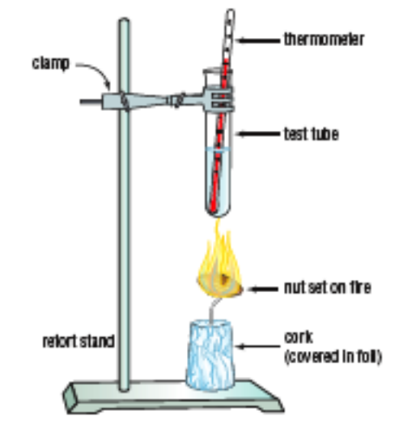

• Adjust the clamp so the test tube is 2–3 cm above the Burger ring.
• Take the measuring cylinder and put exactly 5 mL of water into the test tube.
• Measure the temperature of the water in the test tube. Record it. Leave the thermometer in the test tube.
• Light the Bunsen burner and hold the Burger Ring in the flame. When the nut starts to burn, quickly
move it back under the test tube.
• When the burning stops, use the thermometer to stir the water gently, then measure the temperature of the
water. Record it..
• Work out how many degrees difference there is between the starting and the final temperatures of the
water. Record the temperature change.
• Repeat the experiment for two more Burger Rings.

CALCULATIONS:

• Every 1ºC change in the temperature of 1 mL of water uses 4.2 joules of energy. Use the following
equation to work out how much energy is contained in your Burger Ring.

Energy = volume of water x 4.2 J x temperature change

• Calculate the energy released by each Burger Ring. Record it.

RESULTS:

Mass of Burger Ring  (g) | Initial Temperature of Water (°C) | Final Temperature of Water (°C) | Change in Temperature (°C) | Energy (J)

DISCUSSION:

• Look at the side of the packet - it contains the energy released for 100 g.
• Calculate the energy released per gram using the following equation.

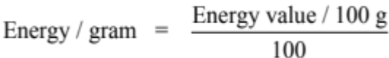
• Choose one set of results and use the following equation to calculate your energy released / gram.

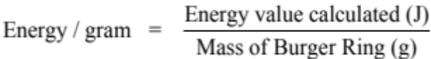

• How do these values compare?

CONCLUSION:

QUESTIONS:

1. Did this experiment give you a good measure of the energy in the nut? If you are not sure, consider whether all
the energy from the Burger Ring ended up in the water.

2. Why is it possible to set fire to foods such as Burger Rings and nuts?

3. There are no actual fires burning in your body to extract the energy from food. What is the name of the
body process that happens in your cells at normal temperatures to obtain energy from food and oxygen?

